Reading Comprehension Icons
by Smekens Education Solutions, Inc.
Retelling/Summarizing Ideas | 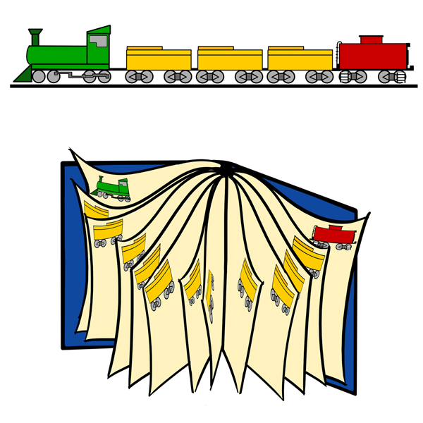
Determining Main Idea | 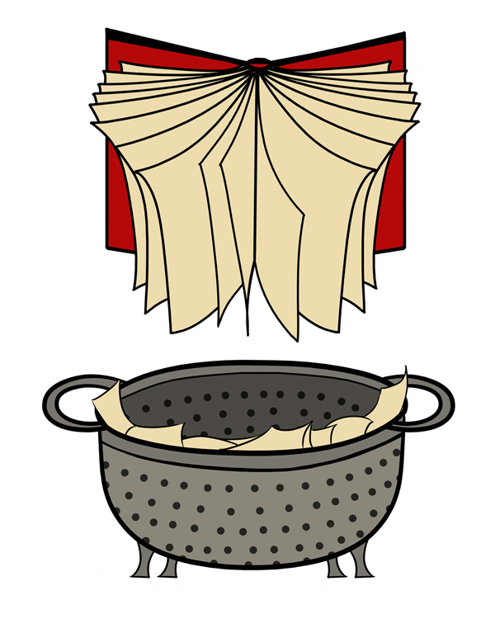
Visualizing Ideas | 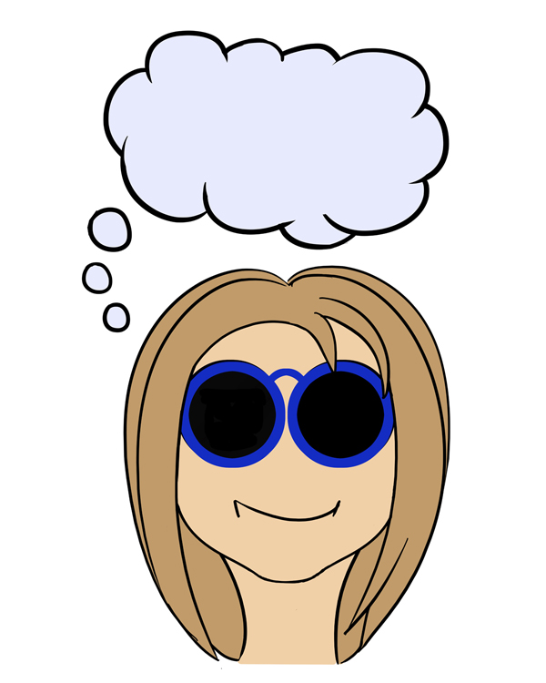
Asking Questions | 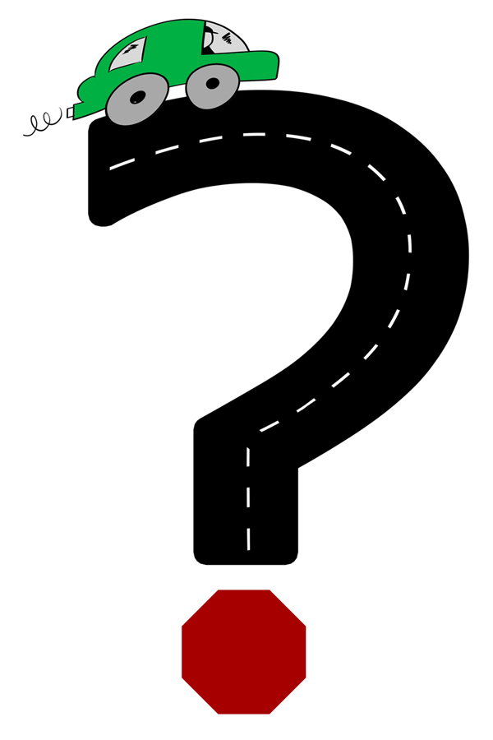
Making Connections | 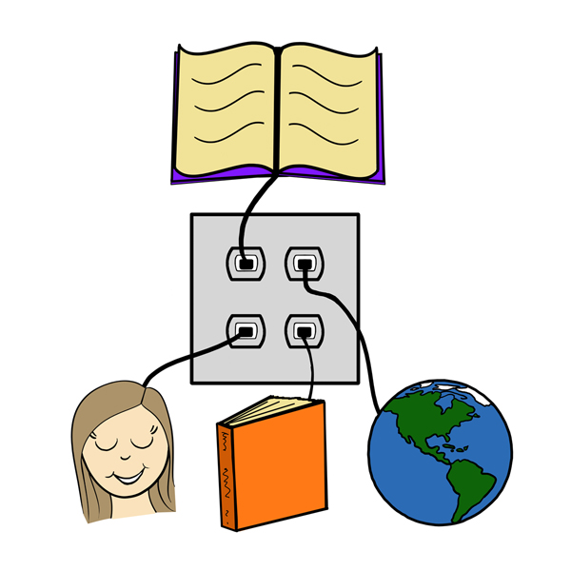
Synthesizing Ideas | 

