Readers____________________________________ .
Let’s review the skill. | Here’s the assignment.
Readers have thoughts while they read.
Let’s review the skill. |  | Here’s the assignment.
Readers have a Reading Voice that reads the words and a Thinking Voice that whispers thoughts.  A reader has MANY thoughts about what they are reading.  A reader has to pause his Reading Voice to hear the quiet whispers of the Thinking Voice. |  | Make your own Reading Voice and Thinking Voice sign.  - Find 1 piece of paper, tape, and a long skinny object.  - Fold the paper in half.  - On one side, draw a green speech bubble.  - On the other side, draw a yellow cloud bubble.  - Tape to the long, skinny object.  While reading ___, use the sign you made.  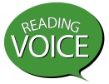Read aloud for a little bit using your Reading Voice.  Then, spin the sign to show Thinking Voice.  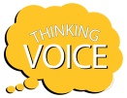Say out loud something you learned and/or wonder.  Spin the sign back to Reading Voice.  Read aloud for a little bit and then stop.  Spin the sign and say out loud what you are thinking.  Continue this process throughout the entire text.
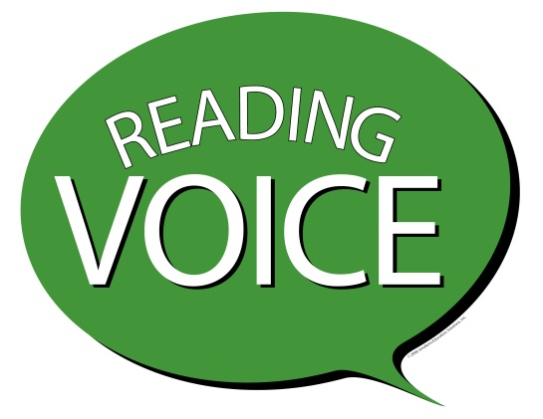 | 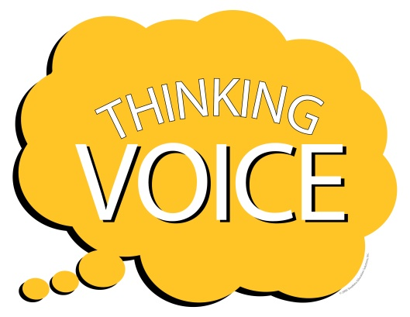

Readers track their thoughts while they read.
Let’s review the skill. |  | Here’s the assignment.
Readers have a Reading Voice that reads the words and a Thinking Voice that whispers thoughts.  A reader has MANY thoughts about what the author is saying.  A reader tracks his thoughts throughout the text.  - A reader underlines or highlights the author’s words when he has a thought.  - A reader adds the thought he had next to the author’s words that caused it.  We called this WHY-LIGHTING—WHY are your HIGHLIGHTING the author’s words? |  | Read ____ and why-light.  While reading, note the thoughts you are having (i.e., Thinking Voice) and the author’s words that caused them (i.e., Reading Voice).  - Digitally highlight and annotate using the tools within the website. (e.g., Newsela, Commonlit, etc.).  - Digitally edit the PDF to include markings and notes (e.g., sticky notes, highlighting, underline, etc.).  - Take a picture/screenshot of the text and open it in your camera roll. “Edit the picture” to include annotations.  - Open the text within __ app and digitally highlight with added notes in the margins.  - Highlight/Underline on the paper-based text and include notes in the margins.
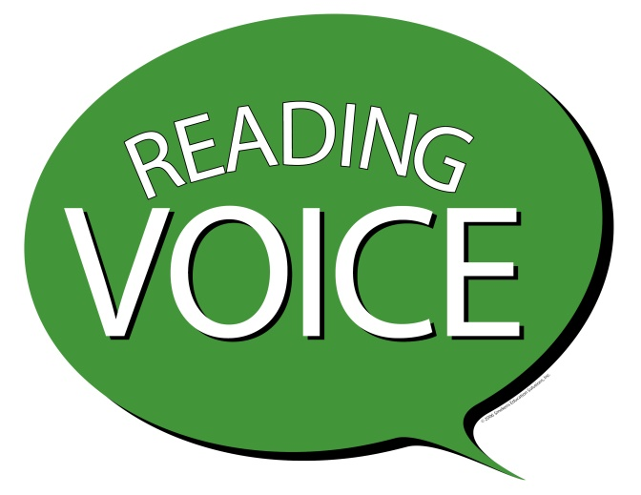 | 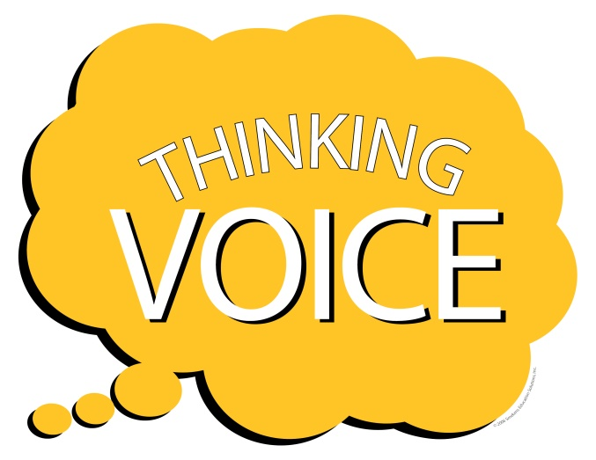

Readers retell/summarize a story (or biography or historical event).
Let’s review the skill. |  | Here’s the assignment.
A retell/summary is multiple sentences.  It includes only the most important information.  When it’s a story—that is the story elements (e.g., character, problem, climax, solution).  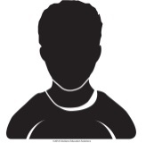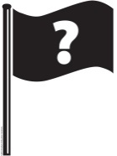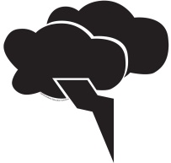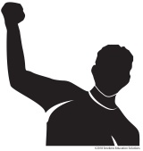  Somebody… wanted… but… so… then… |  | Read ____.  After reading, write a summary using this frame.  somebodY __________________  WANTED ____________________  BUT ________________________  SO _________________________  THEN ______________________
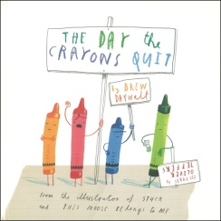  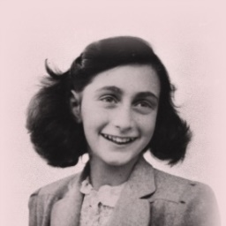 | somebodY Duncan  WANTED to use his crayons  but the crayons were not happy  so they wrote letters to him  then he colored a new way with his crayons.  somebodY Anne Frank  WANTED to hide from the Nazis  but someone turned her in  so she died in a concentration camp  then her diary made her famous around the world.

Readers retell/summarize a story (literature).
Let’s review the skill. |  | Here’s the assignment.
A retell/summary is multiple sentences.  It includes only the most important information about the story—the story elements.  - Character  - Setting  - Problem (situation/conflict, events/episodes, climax)  - Solution (resolution)  The Retelling Glove helps us remember these important parts of a story. |  | Read ____.  Trace your hand.  Write in the information per finger.  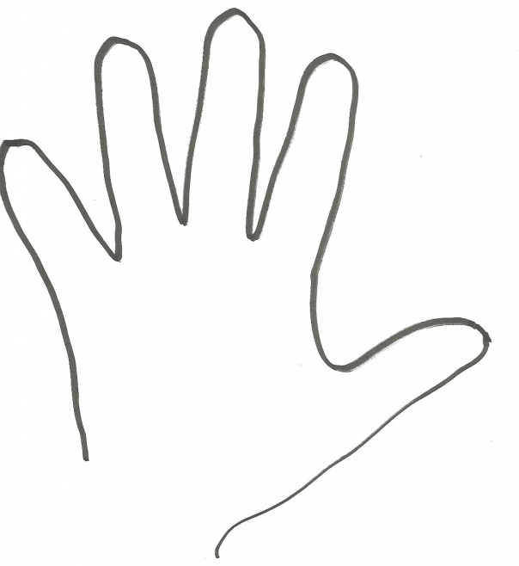
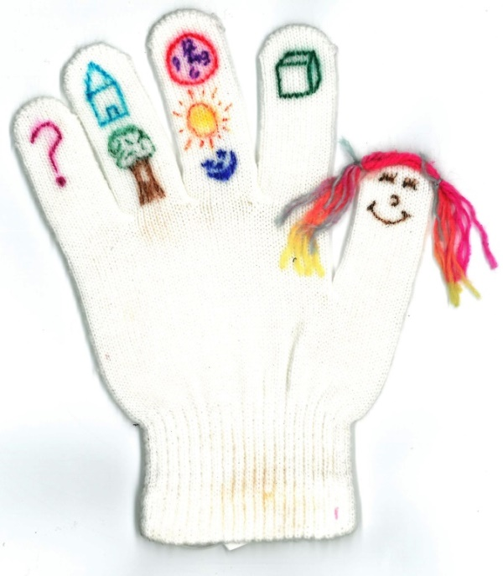 | 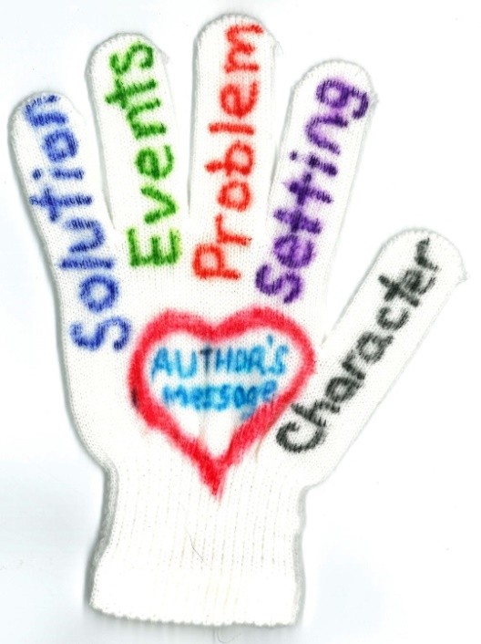

Readers retell/summarize informational text.
Let’s review the skill. |  | Here’s the assignment.
A retell/summary is multiple sentences.  It includes only the most important information.  In nonfiction text, the most important information usually includes:  - WHO (or WHAT) the text is about?  - WHAT does/did it do?  - WHEN/WHERE does/did it happen?  - WHY is it important? WHY it happens?  - HOW help? HOW does it affect… ? HOW is it affected by…? |  | Read ____.  Trace your hand.  Label the fingers.  Write in the information per finger.  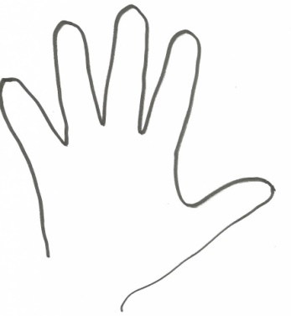
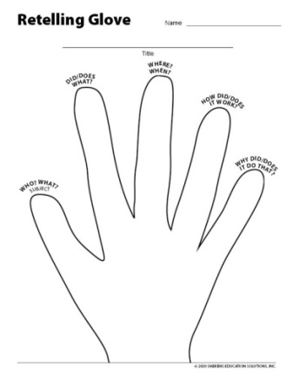 | WHAT: Minerals  WHAT IT IS: A solid, inorganic thing made up of chemicals. Most are made of repeating structures called crystals.  WHAT IT DOES: They can grow and fit together to make rocks.  WHERE DOES IT HAPPEN: This happens in the ground.  WHY IMPORTANT: Minerals are used to build things, fertilize soil, and even clean teeth.  HOW HELP: Minerals are important for people, plants, and animals to eat in order to grow and develop.
Readers determine the main idea of a passage.
Let’s review the skill. |  | Here’s the assignment.
The main idea of a passage is a one-sentence summary.  - It has a beginning-sentence capital letter and period.  - It has a subject and predicate.  - It’s a complete thought.  It includes the topic or subject AND what about it.  - The topic/subject is easy to figure out.  - To figure out the “what about it” part, look for ideas and details that repeat. |  | Read _______.  Write a one-sentence summary of what the text was about.  To make this a little more fun, pretend your main idea has to fit in 140 characters. (This was the maximum length of tweets originally.)  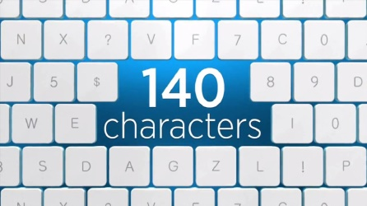
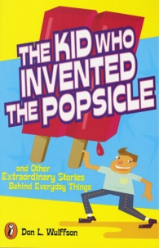 | HOT DOG = A poor-spelling cartoonist named the hot dog after the dachshund dog.  HIGH HEELS = King Louis XIV, a short man, ordered the royal cobbler to make him the first pair of high heels.

Readers determine the theme(s) of a text.
Let’s review the skill. |  | Here’s the assignment.
Theme is the life lesson that the author wants the reader to learn. Life lessons are about how we can be a better person—to ourselves and others.  The reader learns the author’s theme by looking at what the main character learned in the story.  - What was the character’s problem? How did he solve it? What did he learn about being a better person?  - What was the character like at the beginning? What was he like at the end? What did he learn about being a better person?  - What did other characters think of the main character at the beginning? How did they feel about the main character at the end? What did he learn about being a better person? |  | Read ___.  Think about what happened to the main character.  What did he learn about being a better person—what’s the theme?
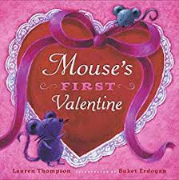. | 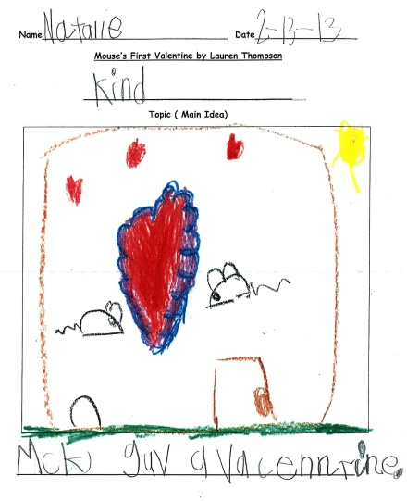 | PRIMARY GRADES:  DRAW what happened in the story.  Then write the THEME at the top of the paper. What lesson did the character learn? | UPPER GRADES:  Write out the theme in a single sentence.  Provide specific examples from the text that prove what lesson the character learned.  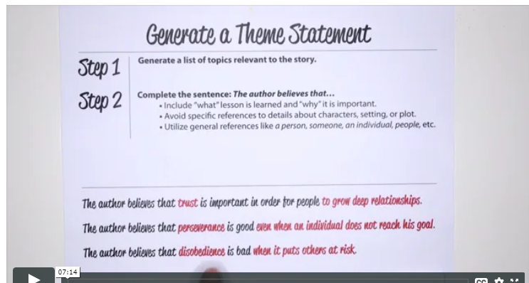
Readers evaluate an author’s argument in informational text.
Let’s review the skill. | Here’s the assignment.
Some informational texts are based on an author's ideas, beliefs, or opinions. Authors present their claims and support them with specific reasons and evidence. They do this to try and convince the reader they are right.  Readers question the author’s argument in 3 steps.  - Identify the author’s opinion, belief, claim, or position on a topic.  - Identify all of the reasons and evidence the author provides for his opinion. (UPPER GRADES: Does it include opposing perspectives?)  - Decide if the author made a strong argument.  REMEMBER!  - Readers can agree with the author’s point but think his argument is WEAK.  - Readers can disagree with the author’s point but think his argument is STRONG. | Read ___ on procon.org.  OR, View __ commercial on iSpot.tv.  OR, Using your smartphone, record any TV commercial from your own television.  Evaluate the author’s argument.  - Draw a table top with several legs on paper (or use the digital download).  - Write the author’s/company’s claim on the table top.  - Write all of the reasons (with evidence) that are provided.  - Below the table and legs, write out your conclusion. Explain if the author/company has presented a STRONG or WEAK argument and why you think that.  (Explain how to submit or turn in the task.)


