Writers____________________________________ .
Let’s review the skill. | Here’s the assignment.
Writers craft narratives.
Let’s review the skill. | Here’s the assignment.
Narratives are about a character’s problem and how it gets solved.  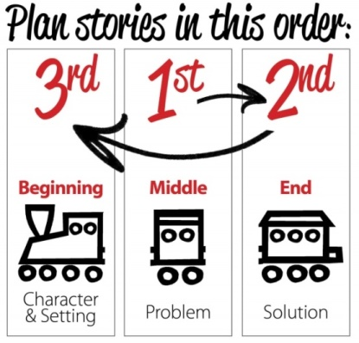  - Narratives always have a problem in the middle. What is the problem your character faces?  - Narratives end with a solution. How does your character fix, solve, or resolve his problem?  - Narratives begin by introducing the character and the setting.  Remember, lots of character description in a detailed setting with NO PROBLEM is NOT a narrative. It’s just a description. | UPPER GRADES: Microfiction is a real genre. It is a narrative story told in 50 words. Write a story about a real or imaginary experience. You must limit it to 50 words.  Before you start writing, plan it first.  - Plan the problem first.  - Plan the solution second.  - List any important info about the character and setting third.  Write/type your story. Remember, you have ONLY 50 words to establish a character’s problem AND SOLVE IT!
PRIMARY GRADES:
Use the handout or draw 3 boxes on a piece of paper. Write/Draw a story about a real or imaginary experience.
- TOP BOX: Who is the character and what is the setting?
- MIDDLE BOX: What is the character’s problem?
- BOTTOM BOX: How does the problem get fixed?
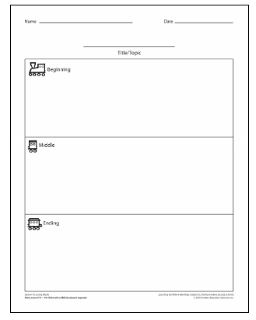
Writers use descriptive language in sophisticated sentences.
Let’s review the skill. |  |  | Here’s the assignment.
Review sentence types…  OR Review sentence structures…  OR Review parts of speech…  OR Review figurative language…  OR Review strong word choice… |  |  | Take an interesting photo of someone or something.  Write a caption that includes the following ingredients:  - (skill)  - (skill)  - Correct capitalization.  - Correct punctuation.  Label each of the skills you used intentionally.  - TYPED-- Bold …., Underline…, Italicize….  - HANDWRITTEN-- Circle…, Underline…., Box…  - HANDWRITTEN-- Red…, Blue…, Green…
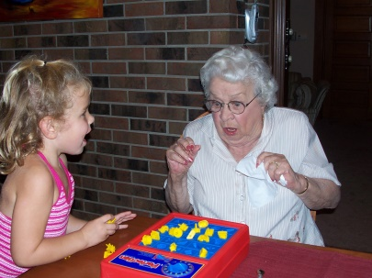3 SENTENCE TYPES  - Sydney and her Nana played a game together.  - Nana jumped when all of the pieces came out!  - Did Nana jump every time? | COMPOUND SENTENCE  Sydney and her Nana played Perfection, and Nana jumped when the pieces popped out.  Compound-Complex sentence  Sydney and her Nana played Perfection, and every time the time ran down, Nana jumped when all of the pieces came out. | Adjectives and nouns  Perfection is a red rectangular box with a springy blue bottom and yellow pieces.  ACTION VERBS  Nana squealed and threw up her hands when all of the pieces popped off the board!  Prepositional phrases  Sydney and her Nana played Perfection in the dining room during their vacation together. |  | Alliteration  Nana jumped when all of the pretty pieces popped out!  Sydney persistently persuaded her Nana to play Perfection.  Personification  Nana jumped every time the game threw the pieces in the air. | Simile  Nana jumped when all of the pieces popped out like popcorn!  Idiom  Nana jumped out of her skin when all of the pieces popped out!
Writers change perspectives.
Let’s review the skill. |  | Here’s the assignment.
Point of view is who is telling the story/information.  The same situation can be retold from different individuals.  Share the thoughts, feelings, words, and actions of only that character’s perspective.  Remember when we did these examples? |  | Take/Choose a new picture.  Write a separate caption for at least three individuals/objects in the image. Consider what they would be thinking, saying, or wanting in this situation.
. | The cow is thinking…  The bird is thinking…  The fly is thinking…  The boy is thinking…  The dog is thinking…  The suitcase is thinking…

Writers paraphrase experts and cite sources.
Let’s review the skill. |  | Here’s the assignment.
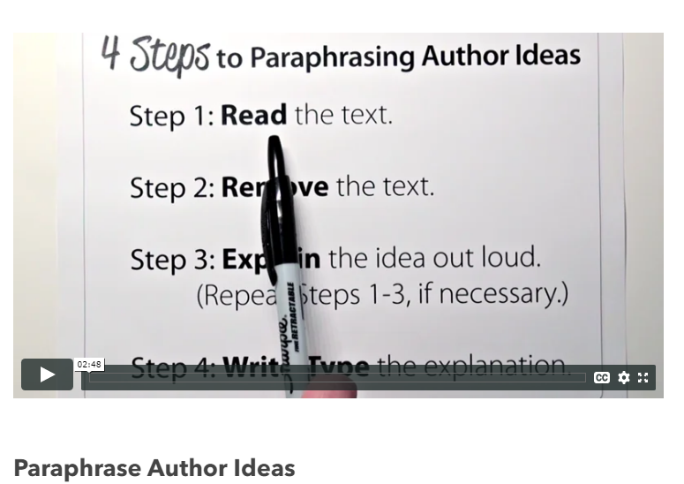 | A paraphrase is someone else’s idea restated in your own words.  Recall the 4 steps and hand signals:  - Read the text.  - Remove the text.  - Explain out loud what it said.  - Write what you said.  TIP: Use synonyms. | Read ____ .  Choose 3 different excerpts/paragraphs from this text to paraphrase.  Execute the 5 steps to paraphrasing—including the citation for each.  After you have written each one, identify which paragraph/excerpt you were attempting to paraphrase.  - Note the paragraph number (P #4).  - Note the line number (Lines 14-19).  - Include a visual snip/grab/screenshot.
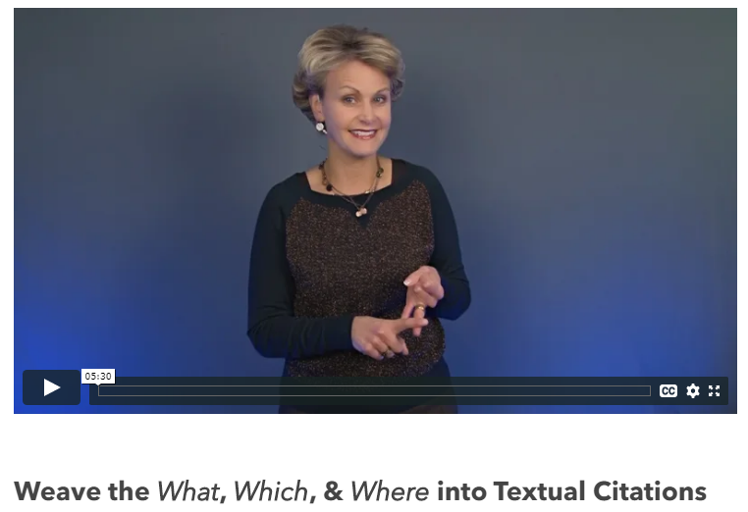 | We added Step 5—the citation!  A citation tells the reader where you found the information.  - WHICH text/source?  - WHERE in that text/source?  According to…  One example comes from…  In ___ it states that…

