Print v. audio texts
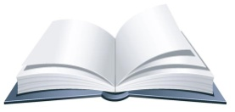 READ and annotate the print text. | 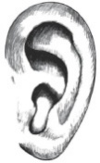 What do you HEAR in the audio version?

