print v. video texts
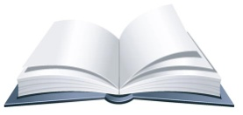  Read & annotate the print text. | 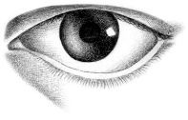  What do you SEE in the video? | 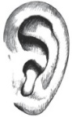  What do you HEAR in the video?

