Dear Parents,

All kindergarten children are at different developmental stages of writing. It is my goal to take them from where they are and help them to move forward. Every child is considered a writer when they come through the door. I would like to share some information with you that will help you to better understand these developmental stages of writing. We will be doing a lot of writing in the classroom and any attempt at this will be praised.

For some children writing may look like this: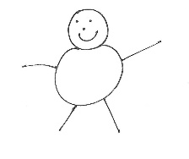
(After drawing, he/she may say, “This says I am happy.”)

For others, it may look like this: 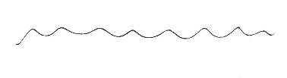 or 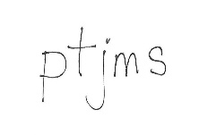
(Afterwards, he/she may say, “This says I am happy.”)

As the children gain knowledge about letters and sounds, it may start looking more like this:
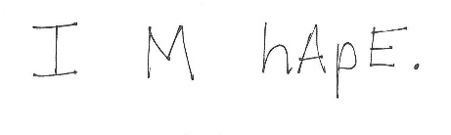

I am asking that you be supportive of these stages at home. Please do not expect your child to always spell words correctly. This will only inhibit a young writer’s desire to write. Rather, praise and encourage any attempts at writing. The correct spellings will come later. Learning to write is similar to learning to talk. First babies babble, then speak a couple words, and eventually they speak in sentences. Be patient and supportive of your child’s efforts with writing, just as you were when he/she was learning to talk.

If you have any questions about your child’s writing, please feel free to ask me. Thanks for your support!

Sincerely,

Dear Parents,

Your children will be learning to write in our class— not just learning letters and understanding that letters represent the sounds of our language, but learning to be authors. Here is what they will be doing and how you can help them:
- They will be selecting topics. You can help by asking them each morning: What will you write about today?
- They will be labeling their drawings and creating messages.
- They will be trying out new writing skills. You can help by asking: What skill or writing trait were you trying to use in this writing? What is the writing skill or trait your class is focusing on this week?
- They will be sharing their writing and asking their peers questions like: Does this make sense? Is this interesting?
- They will be revising by adding details.
- They will be editing their own work all by themselves for spelling, punctuation, and capitalization.
- They will be publishing some of their work.

When you see their work, you can help by talking to them about the content— what the writing is about. Here are some comments and questions that help a young author.
- I like this.... (picture, letter, label, word)
- Did you tell all about the picture?
- Can you tell me more about...?
- What else do you know about this?
- What will your next piece be about?

You, their audience and readers, will need to bear with them as they learn their craft. Receive their writing in the same spirit of encouragement that you do their music, art, and sports performances. That will help them become the best they can be.

Sincerely,

Dear Parents,

Your children will be engaged in the writing process this year. As authors they will pre-write, draft, revise, edit, and publish. They will learn that all good writing has six ingredients— ideas, organization, voice, word choice, sentence fluency, and conventions. They will learn about these 6 Traits of writing through class instruction, conferencing, and by studying real authors.

You can help your children by talking to them about their writing and asking sincere questions. Here are some comments and questions that help a young writer:

- I like the part about....
- Can you tell me more about...?
- What skills/traits were you trying to use in this piece?
- Tell me what happened with more detail.
- How does this piece compare to others you have written?
- What will your next writing be about?

You, their audience and readers, need to bear with them as they learn their craft. Editing standards will be established and the children will practice editing independently. Still, their finished work or published work will not always be perfect. But just as we can all enjoy a band’s performance with the occasional squeaking of a clarinet or a ball game where a ball was missed, so can we enjoy these young authors’ “performances” with the occasional misspellings or omitted period. Receive their writing in the same spirit and encourage them to become the best writers they can be.

Sincerely,

