Three Perspectives PowerPoint
Part 1: Create your Avatar
- Create an Avatar. (An Avatar is a digital cartoon-like figure of a real person.) Go to www.myavatareditor.com.)
- Follow the on-screen prompts to enter information. Create! Click the buttons at the bottom to change the color, shape, and size of the features of your avatar.
- When you have finished, click the DISK ICON in the lower left corner.
- Click the EXPORT button to save your avatar. Click on “PNG” and uncheck “background.”
- Click “SAVE.” When asked, name your file using your name, then “avatar” (e.g., Carly’s avatar).
- Click “SAVE” and exit the avatar program.

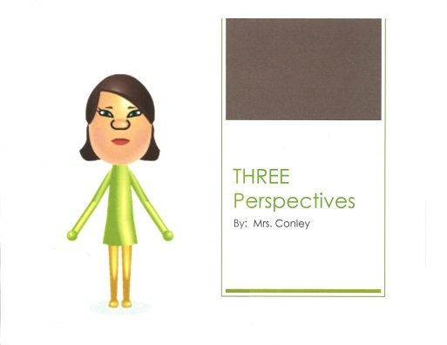
Part 2: Open a PowerPoint/Create Slide 1
Slide 1
- Open PowerPoint either on the desktop or in the START menu.
- Go to DESIGN in the menu bar and choose a background for your first page.
- Click in a text box to type your title: Three Perspectives By: ______
- In the menu bar, SAVE your PowerPoint.

Part 3: Inserting your Avatar
- In the menu bar, go to INSERT/PICTURE.
- Find your avatar picture. (TIP: Be sure the drop-down menu says “All Files.”) Double-click on it to insert the avatar onto your page.
- Resize the avatar and move it to the desired location.
- In the menu bar, SAVE your PowerPoint.

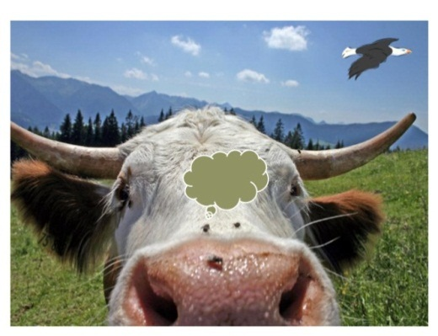
Part 4: Adding Slides 2-4/Adding background picture
Slide 2
- In the menu bar, go to HOME. Click on NEW SLIDE.
- Go to INSERT/PICTURE in the menu bar. Find the file entitled “Photos for Perspective Project.” Choose the ONE you will use.
- Get rid of the text boxes and resize your photo.
- You will now right click on page 2 (the small one on the side) and choose “Duplicate Slide.”
- Repeat this process until you have 3 slides all with the same photo.
- Click on the disk icon to SAVE your PowerPoint.

Part 5: Adding transitions between pages
- In the menu bar, go to TRANSITIONS. Choose from the large variety of transitions by using the drop-down arrow. You may choose ONE for the entire project and click on “apply to all” over to the right, OR you may choose a different one for each page.
- Click on the disk icon to SAVE your PowerPoint.
Page 3
Part 5: Add text bubbles
- Click on INSERT/SHAPE. Choose one of the shapes.
- Once back on the photo, CLICK and DRAG to make the text bubble. Resize and change the color. Do this by clicking on FORMAT. Select a white background. You may also change the outline.
Page 4
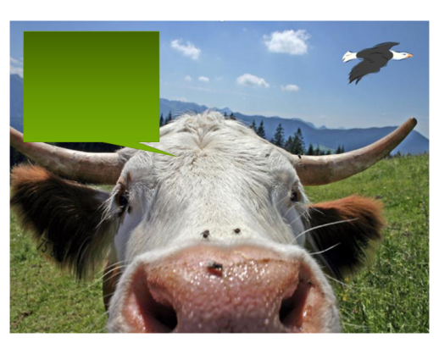
- Create ONE text bubble for each character in the scene.
- When you know what you want a character to say/think (based on his perspective), CLICK inside the bubble and type. Remember to use first-person point of view (e.g., I and me). Resize your bubble and text for readability.
- Click on the disk icon to SAVE your PowerPoint.

