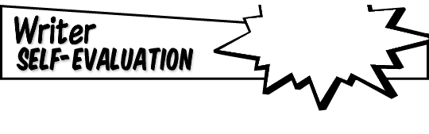

**How many total # of sentences are in the narrative?**

**In which sentence # is the problem revealed?**

**In which sentence # is the solution revealed?**

**What events/episodes in the middle make the problem/conflict   
worse?**

**NARRATIVE**

**Next to each character listed above, identify how many sentences of dialogue each speaks.**

**Why is this effective for your particular story?**

**Name:**

**What is the main problem in your narrative?**

**What technique did you use to get the reader’s attention at the beginning of your narrative (e.g., establish the situation, introduce characters, describe setting, start with action, etc.)?**

**List the main character(s) and one important detail/trait about each.**

**If you could   
revise any part of your   
narrative, what would you   
add, delete, rearrange, or clarify?**