TO VIEW THIS DOCUMENT: Go up to the word “view,” then slide down to “print layout.”



P.O. Box 332 Warren, IN 46792 – 888-376-0448 – www.SmekensEducation.com

Smekens Education Solutions, Inc. is happy to provide you with a series of simple icons to represent the 6-Traits of Writing. To make these icons meaningful to your students, we encourage you to use them consistently whenever you teach writing. (For example, use them as part of classroom posters, student bookmarks, bulletin boards, handouts for writer’s notebook.)

To make your own resources using these icons, follow this simple process:
- Select the icon you want to use (click on it)
- Go up to the word “edit,” then slide down to “copy.”
- Go to the document where you want to use the icon. (Another Word document, Microsoft Works, or MS Publisher, for example)
- Once you’re in the new document, go up to the word “edit,” then slide down to “paste.”
- Now that the icon is in your new document, you can make it larger or smaller. To keep the proportion, be sure to hold down on the “shift” key as you change the size.




Ideas
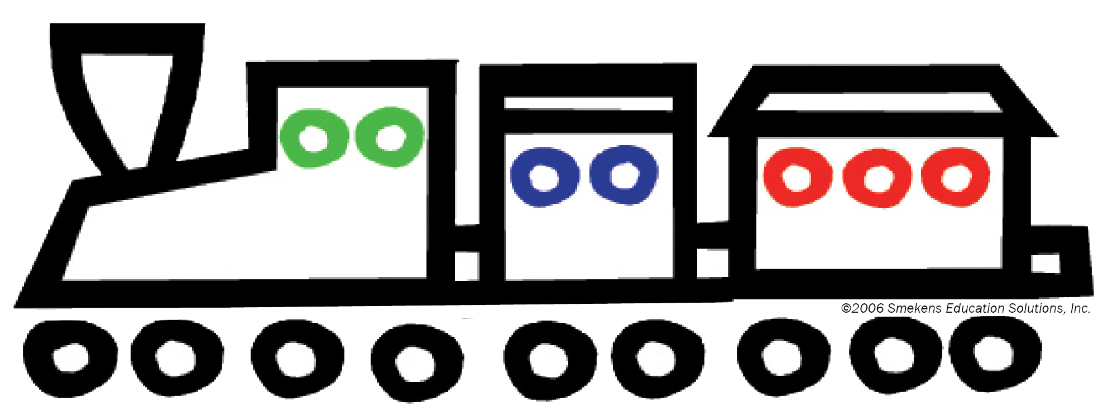
Organization

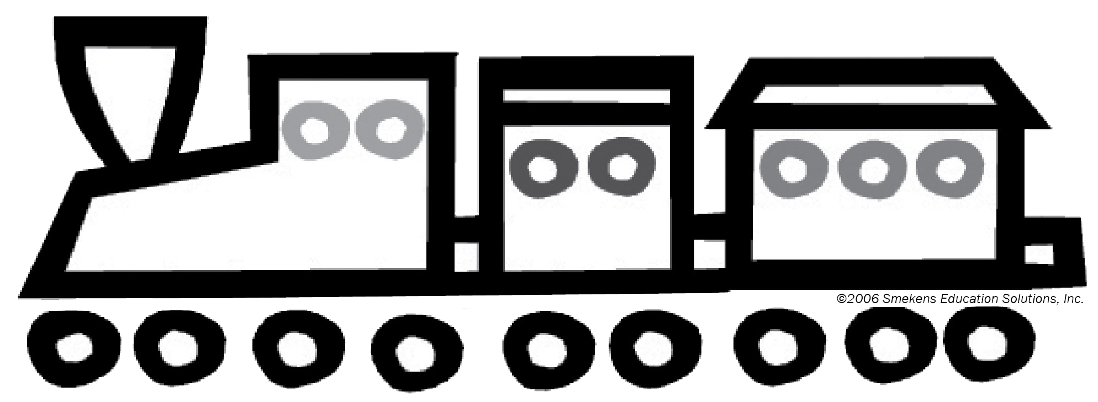
Voice


Word Choice
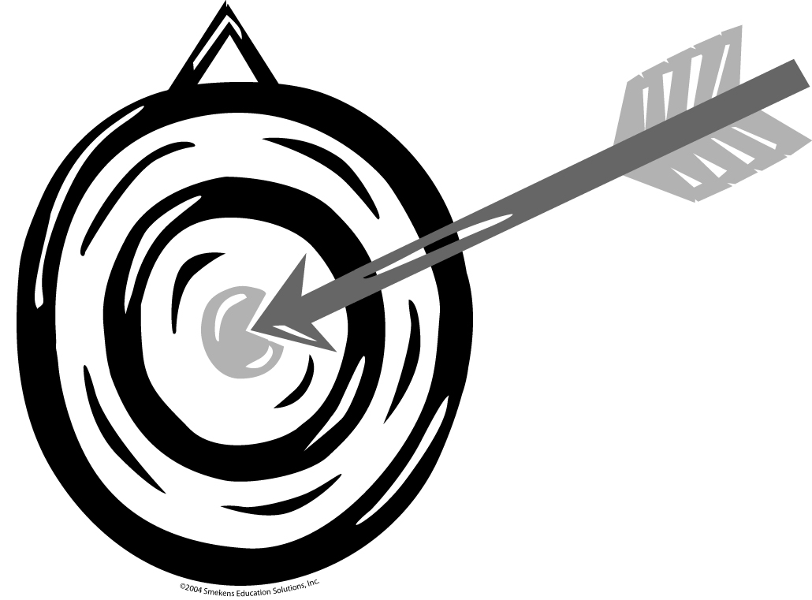

Sentence Fluency



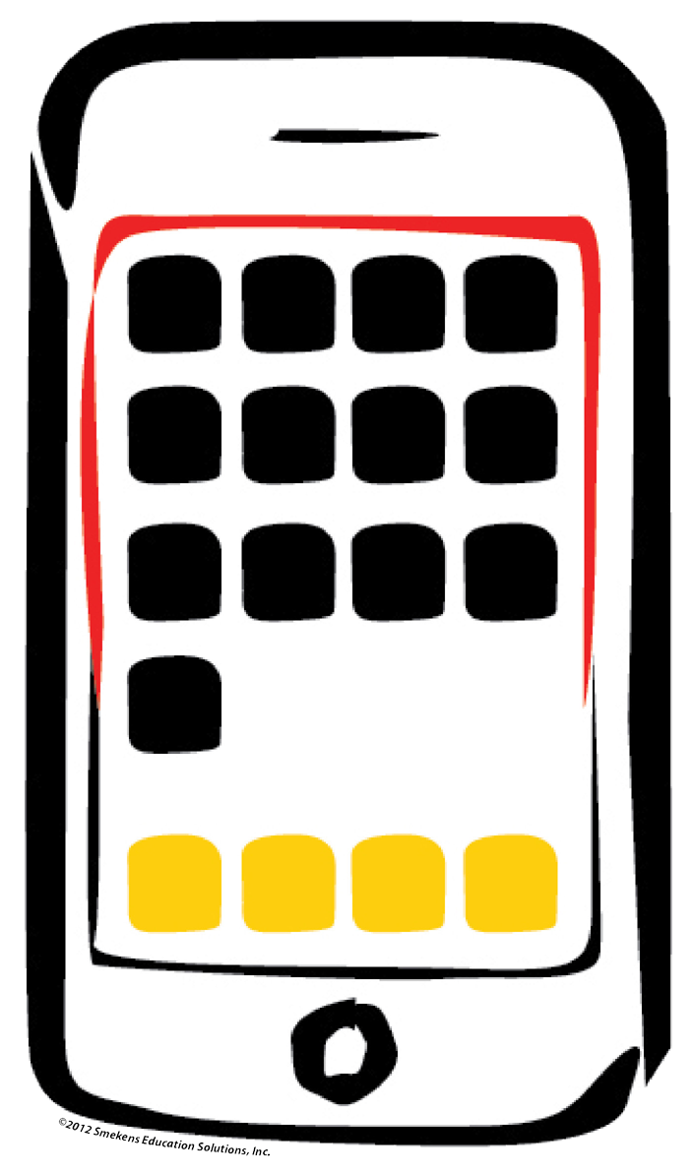
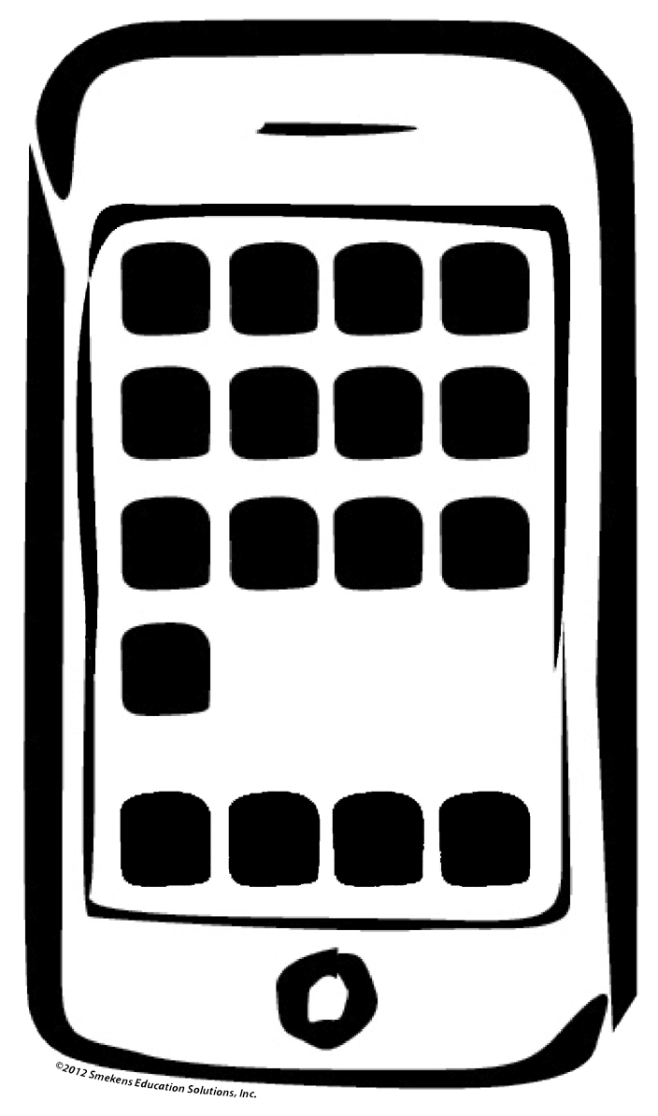
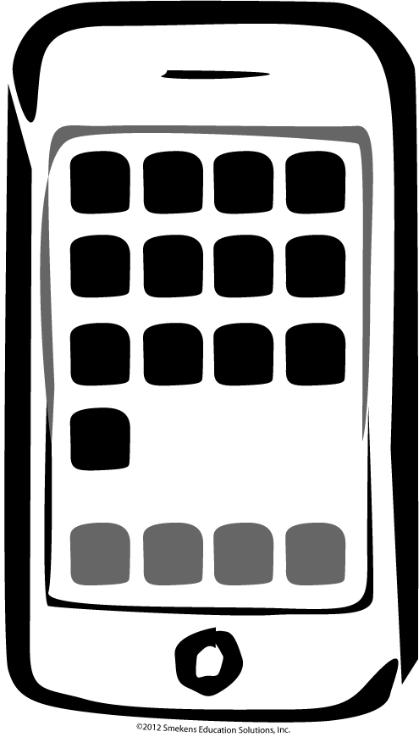
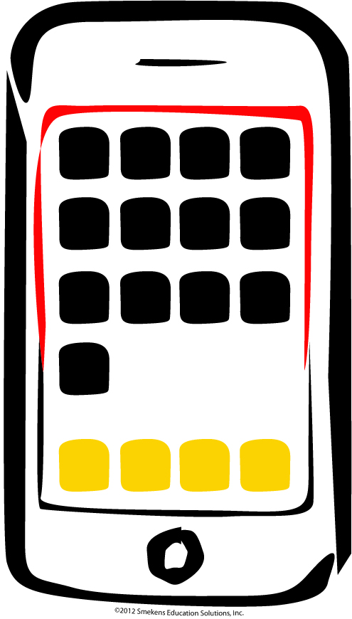
Sentence Fluency
Conventions
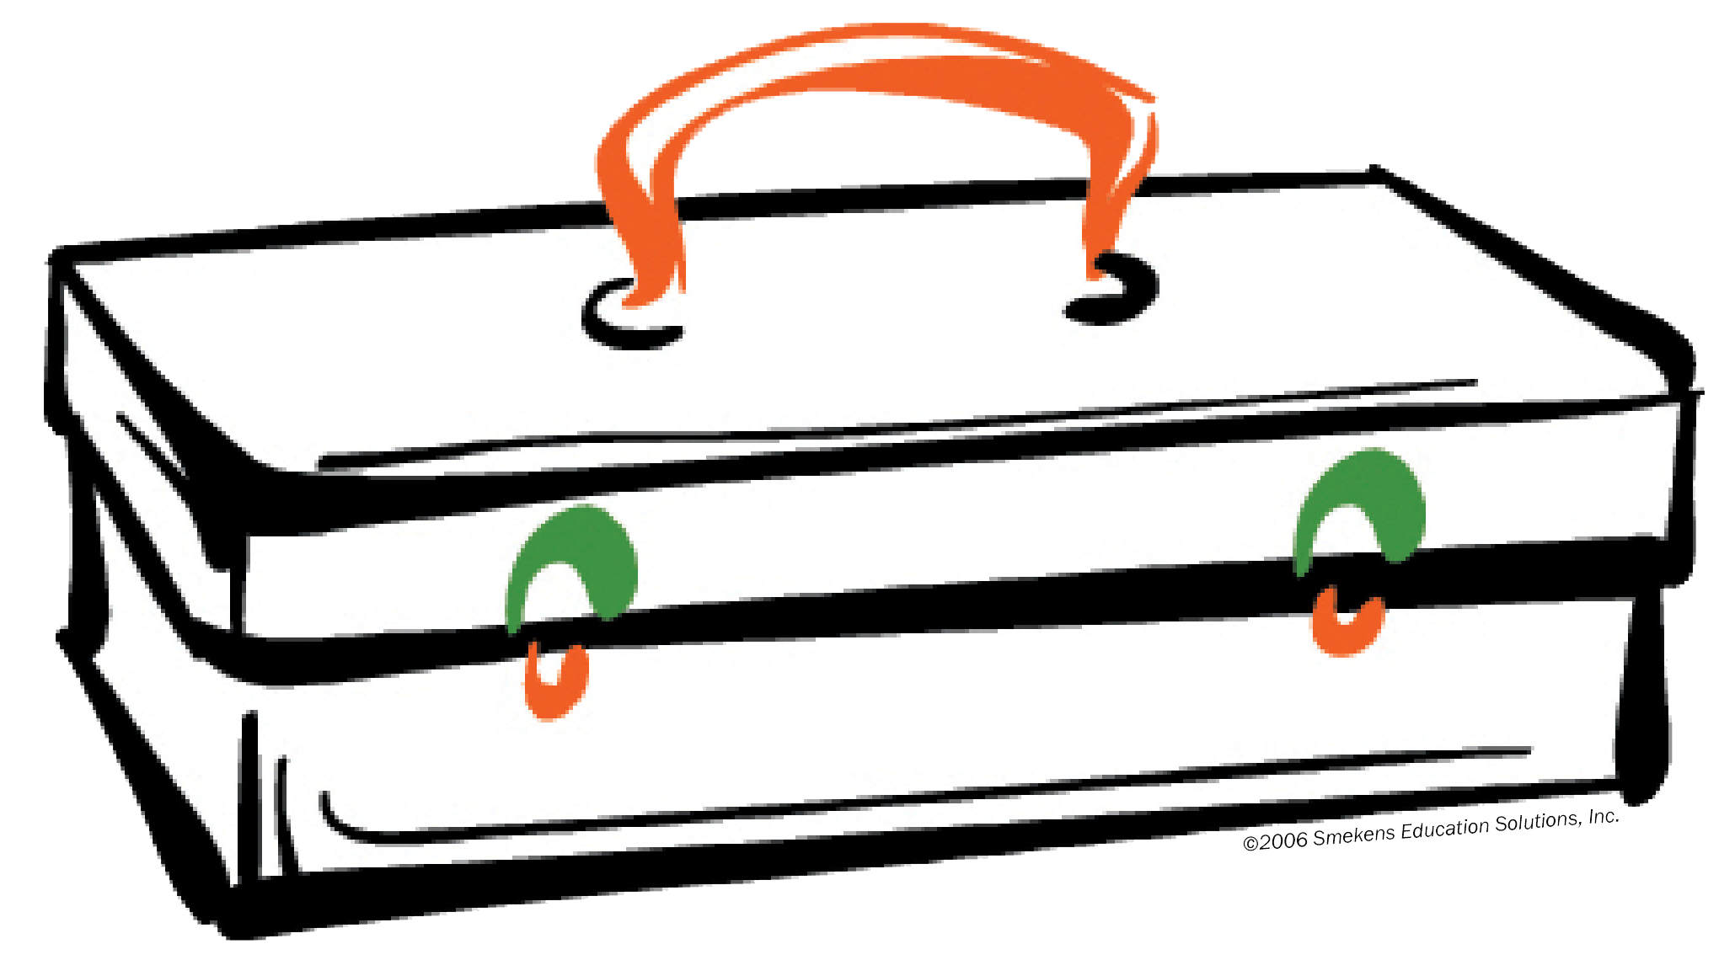
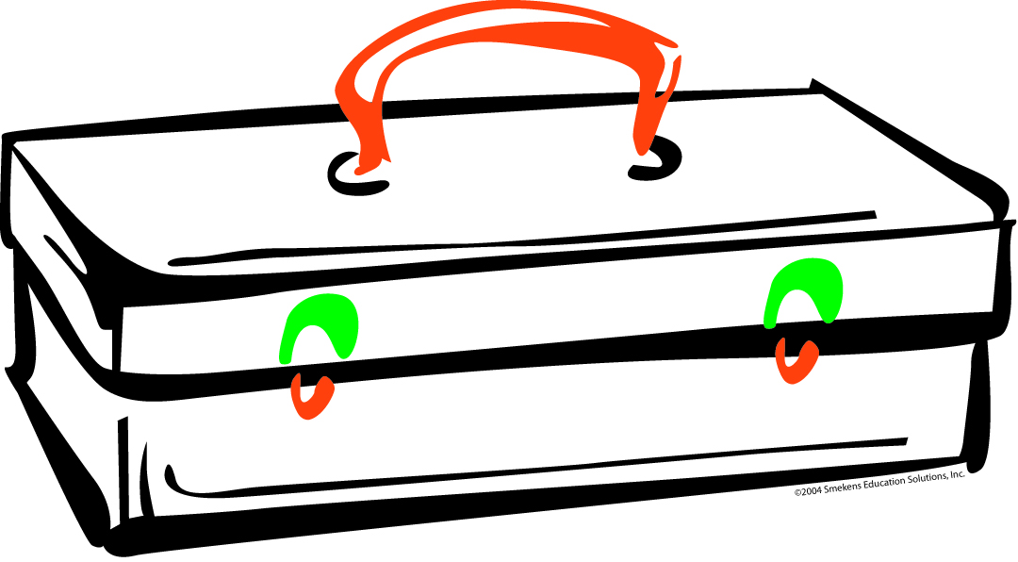




Conventions
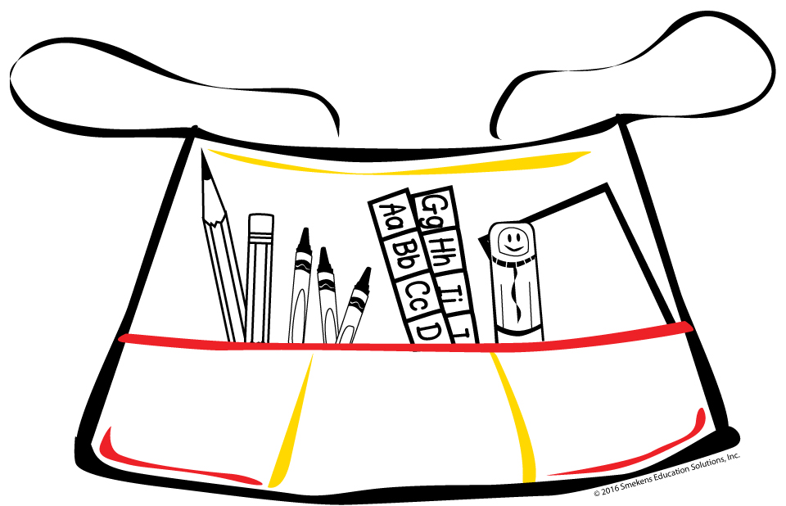
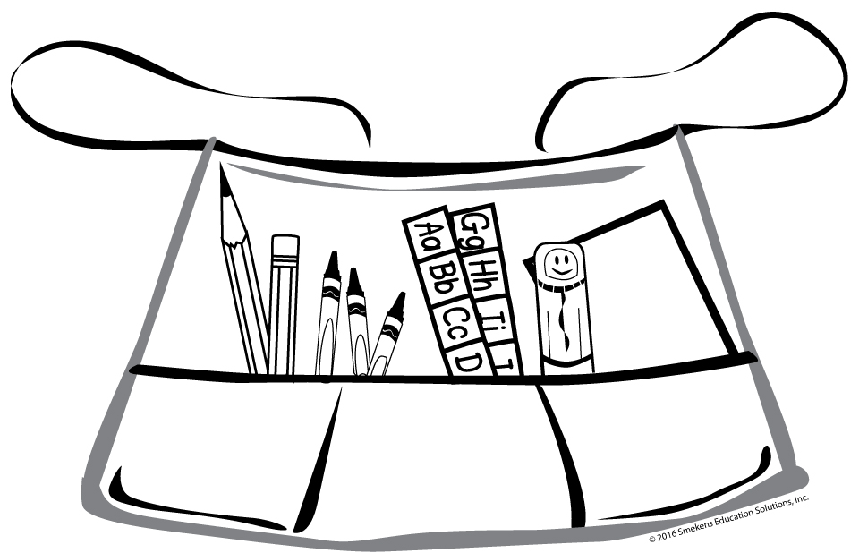
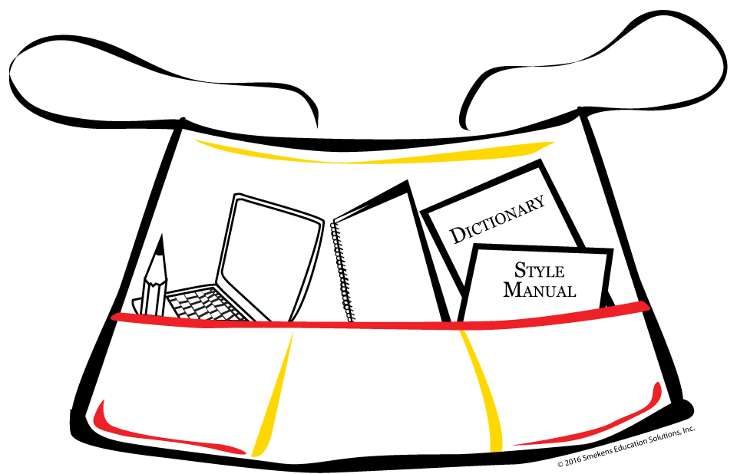
Conventions

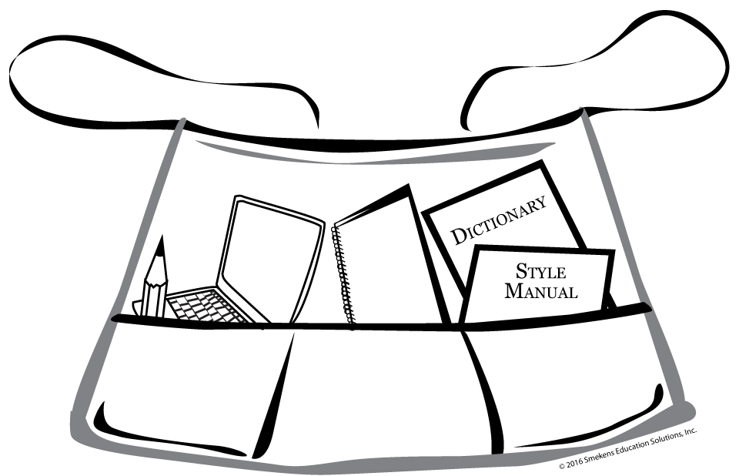
Presentation



