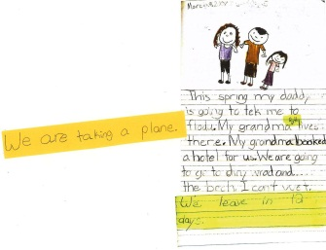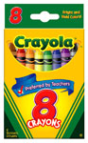

HELP!

I have a question, but I can keep writing.

Mini-Lesson #6 – Support writers when they need help 2018 Smekens Education Solutions, Inc.

Section 2: *Setting Expectations Launching the Writer’s Workshop: Grades K-2,* Kristina Smekens & Linda Schmidt

While I am waiting …

Add 1 spider-leg sentence.

Add 2 WOW! words to your writing.

Add 3 color details to your picture.

Check for spaces between all your words.